In February of 2021 broadcasting minister Kris Faafoi announced that the New Zealand Government is putting $55 million into public interest journalism. This media funding package has been sourced from the Covid Recovery Fund and aims to support Aotearoa owned media companies. For this fund, public interest journalism is defined as ‘journalism that contributes to a person’s ability to function as a valued and informed member of the communities in which they live and/or work[1]’. The minister said public journalism was important not only to keep the public abreast of information that affected them, but also to support ''a healthy democracy by holding voices of influence to account.”[2]. This then raises the question as to what specifically the $55 million should go towards. Will the government only fund journalism focused on spreading researched, accurate and informed information about government related issues or instead focus on funding journalism that contributes to uplifting the voices of the Aotearoa public on issues related to the wider population. This essay will answer the question of what the money should be spent on using my personal opinion, whilst taking into account the context to the fund, and Aotearoa’s public trust in the media.

The public interest journalism fund is the second large media fund to come out of the covid recovery fund, following a $50m media support package announced at the height of the pandemic last year, which provided short-term cash flow relief to media firms facing big drops in advertising revenue during lockdown[3]. This initial problem of advertising revenue dropping is an issue that the government was a catalyst in. During the covid lockdown the government put large amounts of money into advertising on large media platforms such as Facebook and Google in order to reach the most people possible. Whilst effective, this advertising strategy took revenue away from already struggling Aotearoa owned media. Alongside the government's advertising, Facebook and other social media distributed articles researched and written by Aotearoa media companies for free. The overall impact of the government's advertising choices led to large numbers of pay cuts and redundancies across the Aotearoa media industry. The public interest journalism fund aims to not only to continue repairing the damage caused to the media industry during the 2020 lockdown, but also to make the media that the population read and trust to be Aotearoa owned.

New Zealanders trust in the media that spreads news has declined overall from 2020 to 2021. In a research report published by AUT’s research centre for Journalism, Media and Democracy (JMAD) written by Dr Merja Myllylahti and Dr Greg Treadwell. The overall trust in the news in Aotearoa sat at 53% in 2020. This percentage decreased by 5% in 2021 with only 48% of respondents having trust in the news. These figures can be seen in the graph included below, all rights belong to Dr Merja Myllylahti and Dr Greg Treadwell.

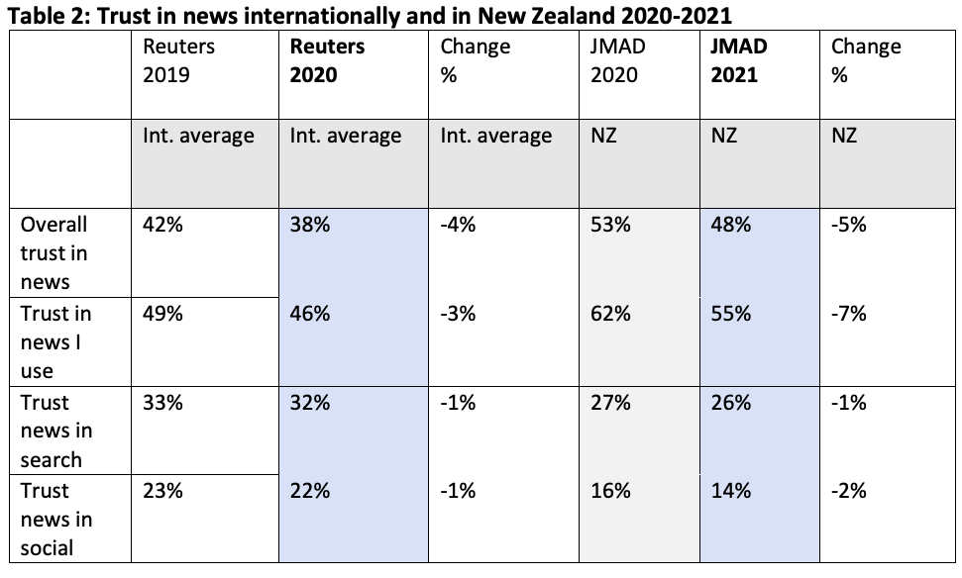

This overall lack of trust in the news is where I believe the focus of the public interest journalism fund should begin. In the JMAD report, a list of common reasons survey participants did not trust the news is created.

*Some reasons for mistrust:*

*• Political bias, especially in talkback radio: “they are pretty right-wing”*

*• Politicisation of media*

*• Media is pushing certain social/other agenda (including climate change)*

*• Media offers opinions, not factual news and information*

*• Not offering a full picture of the events*

*• Selective reporting*

*• Poor standard of journalism including poor sourcing, factual mistakes, poor grammar and low standard of writing.[4]*

I would like to focus on two of these reasons for mistrust ; The **politicisation of media** and **selective reporting**. The ‘politicisation of the media’ is an issue that is particularly relevant to the public interest journalism fund. Especially since the covid pandemic reaching Aotearoa there has been a definite increase in political agendas and information being spread throughout the media. Although this has been essential in some cases I can personally understand the frustration others feel at the constant political nature of reporting. It makes articles seem less genuine, independent, and relatable. There seems to often be a lack of human voice or opinion within articles, making it difficult to find different viewpoints. A lack of viewpoints results in a lack of trust. A participant of the JMAD survey commented that *“good well written accurate, factual reporting is hard to find as everything is sanitised, politically corrected or sensationalised for clicks or sales.”* Another participant said that *“the problem with the news is that it is no longer the news. It is one side of an opinion and the other sides are left out of the story.*”. These quotations provide evidence that a large portion of the country finds the news to be too censored and biased. This then leads to the issue of ‘selective reporting’. It is not an unknown truth that the media often tells the story of white pākehā males within Aotearoa’s society. Minorities such as Maori, Pasifika and Asian people (especially women), as well as the LGBTQIA+ community (please note I am not comparing the experiences of racism to that of homophobia), are often either not reported on, and when they are, the articles are often overpowered by ‘more relevant’ white figures. This process of picking and choosing stories and sides to report on takes away from the authenticity of the information being spread and once again makes the news and media seem removed from the public and reality of living in Aotearoa.

After looking at the context of the public interest journalism fund and researching some of Aotearoa's opinions on the current media I have come up with an answer to the question; ‘How would I spend the $55 million that has been earmarked for public interest journalism?’. Firstly, it has become very clear over the past year how important public interest journalism is for relaying government approved and accurate information to avoid a wide belief in fake news and conspiracies. Therefore I would make sure a cut of the money goes directly towards funding media companies to report on the actions and choices of our Aotearoa government in a well informed and unbiased manner. An example of this could be writing about the ‘go hard and go early’ approach to the pandemic but not bring in a personal opinion about the people or party involved in making these decisions.

After making sure the government is being accurately reported upon and the information that is crucial for every New Zealand resident to know is being shared appropriately I would then like to focus attention on the voices of minorities. A portion of the $55 million should be set aside exclusively for people of colour, people with disabilities and members of the rainbow community in Aotearoa to fund media products where they get to share their communities voices and opinions on matters and inform the wider population. I would like to bring the focus back to what has been defined as public interest journalism. For this fund, public interest journalism is defined as ‘journalism that contributes to a person’s ability to function as a valued and informed member of the communities in which they live and/or work’[5]. Giving voices to minority groups within Aotearoa strongly contributes to Kiwis abilities to function as a valued and informed member of the Aotearoa community as they will be able to get the different viewpoints and opinions that seem to be missing in the current Aotearoa mainstream media.

I would then spend a portion of the $55 million on providing online versions of each daily newspaper around Aotearoa. Whilst a lot of Aotearoa newspapers do have online versions and websites I think that in order to truly boost public interest journalism and Aotearoa owned/produced media these websites need to be available for all newspapers and have good usability. Compared to the media giants like ‘Stuff’ and ‘Newshub’ the aesthetics and readability of many regional papers webpages are very subpar. This makes less people want to read them as they are hard to use and navigate. Putting money into making good quality online Aotearoa newspapers and news sites will not only help to future proof the industry, provide jobs for those in the tech industry and make approved and well-researched news more accessible to the public, but it will also give more opportunities for advertising and other forms of revenue. Creating a solution to what accelerated the industry's downfall in the first place.

To conclude, whilst I believe that the $55 million that the government has set aside for public interest journalism is an amazing initiative. However, I think we need to think about not only using the money to get the industry back on its feet but also to improve ongoing issues. After looking at statistics surrounding New Zealanders trust in the media key issues were brought up. These are what I looked at and took into consideration when deciding how I would spend the $55 million. To summarise how I would spend the money into one sentence, I would split the $55 million between three main things, spreading important political and health information to the wider population, giving minority groups a platform to share things important and relevant to all of Aotearoa from their perspective, and creating engaging online places to find and read news whilst knowing it is correct and reliable information. All three of these uses fit into the definition of public interest media in relation to the fund: ‘journalism that contributes to a person’s ability to function as a valued and informed member of the communities in which they live and/or work’. The biggest changes that need to be made, in my personal opinion, is the digitalisation of online media and getting different viewpoints and representations published. Future proofing the industry and representing everyone. Although the full $55 million does not need to go purely towards the three things I have suggested I think that it would be to the benefit of the Aotearoa population that some money was invested and changes made. It’s good to get the New Zealand media industry back up and going, but it's even better to improve the trust in the media and combat ongoing issues.

1. "Public Interest Journalism Fund | Ministry for Culture and Heritage." 23 Jul. 2021, <https://mch.govt.nz/media-sector-support/journalism-fund>. Accessed 27 Aug. 2021.
2. "Govt injects $55m more into public interest journalism | Stuff.co.nz." 12 Feb. 2021, <https://www.stuff.co.nz/business/124222560/govt-injects-55m-more-into-public-interest-journalism>. Accessed 27 Aug. 2021.
3. "Govt injects $55m more into public interest journalism | Stuff.co.nz." 12 Feb. 2021, <https://www.stuff.co.nz/business/124222560/govt-injects-55m-more-into-public-interest-journalism>. Accessed 27 Aug. 2021.
4. "Trust in news in Aotearoa 2021 - AUT." 29 Apr. 2021, <https://www.aut.ac.nz/__data/assets/pdf_file/0005/507686/Trust-in-News-in-NZ-2021-report.pdf>. Accessed 27 Aug. 2021.
5. "Public Interest Journalism Fund | Ministry for Culture and Heritage." 23 Jul. 2021, <https://mch.govt.nz/media-sector-support/journalism-fund>. Accessed 27 Aug. 2021.