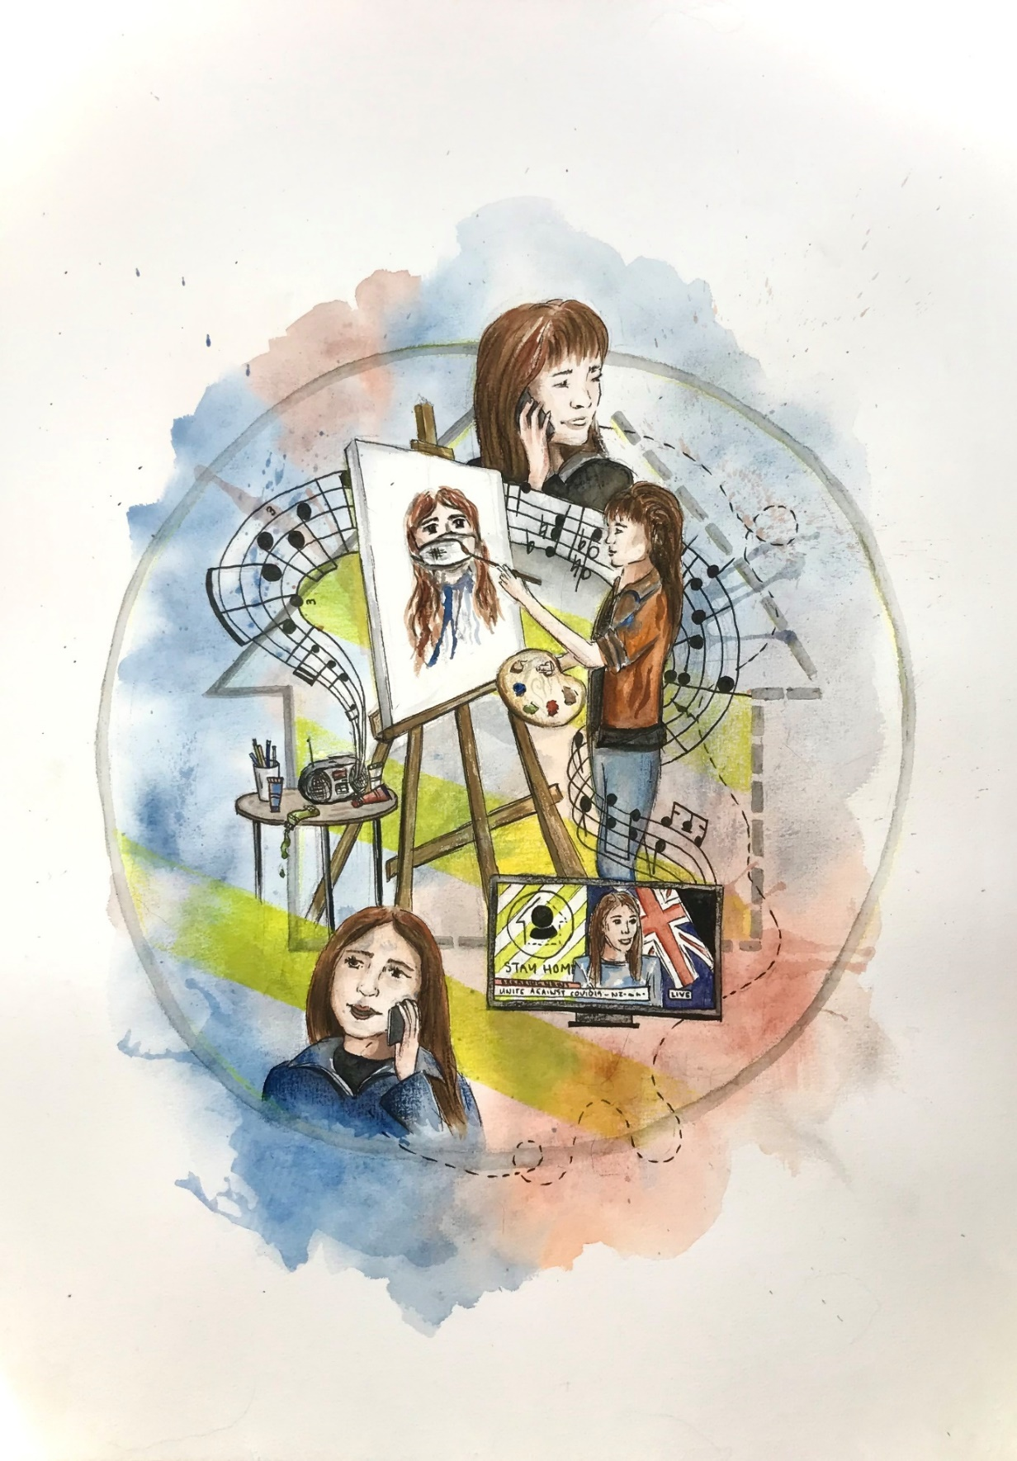

My media life under lockdown was positive, which is depicted in my painting. Most of my time was spent creating and consuming media; I constantly painted, and while doing so, listened to music and/or the news. Making media in lockdown allowed me to have a positive escape from the fears surrounding the pandemic. Listening to music created a relaxing environment to work in, which many other people can relate to. Another positive aspect of media life in lockdown was staying connected through phone calls and social media. We were all stuck inside our own bubbles (as represented in the painting through the covid alert bubble), it was integral to maintain contact with family and friends. Media on the TV such as Jacinda’s regular updates were also positive in terms of staying aware of what was going on outside our bubbles. Positivity in the media, and the knowledge that New Zealand was doing the best we could was reassuring to see everyday. Overall, media was essential in order to stay sane during lockdown life. I appreciate what we have in this day and age, and am extremely glad that we have the resources to create and consume media as we did.

